**AI-Driven Exploration and Prediction of Company Registration Trends with Registrar of companies (RoC)**

**TEAM MEMBER**

**AU620121243057 : VIGNESH.G.A**

**Phase 4 submission Document**

**Project: AI-Driven Exploration and Prediction of Company Registration Trends with Registrar of companies (RoC)**

**Phase4: Development part 1**



**Introduction:**

* In today's fast-paced business landscape, the Registrar of Companies (RoC) plays a pivotal role in tracking company registrations. With the advent of Artificial Intelligence (AI), companies are now harnessing its power to gain insights, streamline processes, and predict trends related to RoC registrations. This AI-driven approach revolutionizes how businesses interpret and anticipate company registration data, offering valuable insights for informed decision-making and regulatory compliance. In this discussion, we will delve into the exciting realm of AI-driven explanations and predictions of company registration trends with RoC, exploring its significance and potential impact on various industries.

**Training a model for predicting the success of an AI-driven company using ensemble learning involves several steps:**

1. Data Collection: Gather relevant data about AI-driven companies. This data can include financial metrics, market trends, company size, and more.

2. Data Preprocessing: Clean and preprocess the data, handling missing values, outliers, and standardizing or normalizing features.

3. Feature Selection: Choose the most relevant features that can help in predicting the success of AI-driven companies. This may involve feature engineering as well.

4. Data Split: Split the data into a training set and a testing set to evaluate the model's performance.

5. Model Selection: Choose different machine learning models that can be part of the ensemble. Common choices include decision trees, random forests, gradient boosting, and neural networks.

6. Ensemble Creation: Create an ensemble of models by combining predictions from multiple base models. Common ensemble techniques include bagging (e.g., Random Forests) and boosting (e.g., AdaBoost or Gradient Boosting).

7. Training: Train each base model on the training data.

8. Prediction: Use the trained ensemble to make predictions on the test data.

9. Evaluation: Evaluate the ensemble model's performance using appropriate metrics like accuracy, precision, recall, or F1-score.

10. Hyperparameter Tuning: Optimize the hyperparameters of the individual models and the ensemble to improve performance.

11. Interpretability: Consider interpreting the ensemble model to understand which features are most important for predicting success.

12. Deployment: Once satisfied with the model's performance, deploy it for making predictions on new data.

Keep in mind that building a predictive model for company success is a complex task, and the quality of predictions depends on the data quality and the choice of algorithms. Regular updates and retraining are often necessary to adapt to changing market conditions.

**The data contains 17 columns which are as follows:**

The specific columns or data fields in a company's details can vary depending on the context and the purpose of collecting the information. However, in a typical dataset or database containing company details, you might find the following common data columns:

1. Company Name: The official name of the company.

2. Company ID or Registration Number: A unique identifier for the company.

3. Company Type: The legal structure of the company (e.g., LLC, Corporation, Partnership).

4. Industry or Sector: The industry or sector to which the company belongs (e.g., technology, healthcare, finance).

5. Location: The company's physical address or addresses, including city, state, and country.

6. Contact Information: Contact details for the company, such as phone numbers and email addresses.

7. Founding Date: The date when the company was founded.

8. Company Description: A brief description of the company's mission, products, or services.

9. Financial Data: Information on revenue, profit, assets, and liabilities.

10. Ownership Structure: Details about the ownership of the company, including major shareholders.

11. Leadership Team: Information about key executives and leadership roles within the company.

12. Employee Count: The number of employees working for the company.

13. Website URL: The company's website address.

14. Social Media Links: Links to the company's social media profiles (e.g., LinkedIn, Twitter).

15. Recent News or Updates: Information about recent developments or news related to the company.

16. Partnerships and Alliances: Details about partnerships or collaborations with other organizations.

17. Awards and Recognitions: Any awards or recognitions received by the company.

The specific columns may vary depending on the purpose of the data collection and the industry. For financial analysis, you might find more detailed financial statements, while for marketing purposes, you might focus on customer-related data. It's important to define the data columns based on your specific needs and goals when collecting and organizing company details.

**GIVEN DATASET:**

**Totally we have an 1,50,872 data’s so we take some data’s in our dataset.**

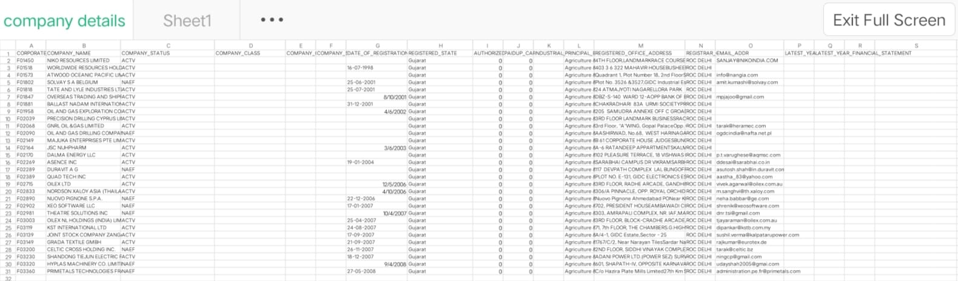

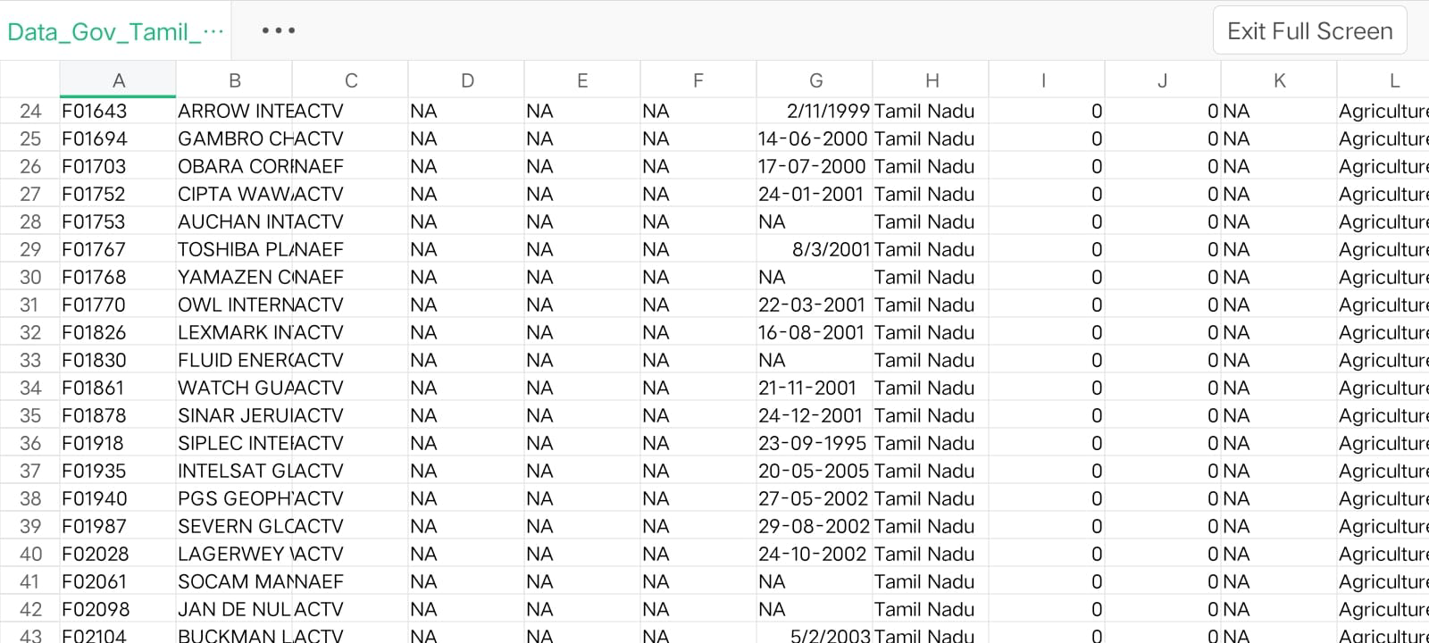

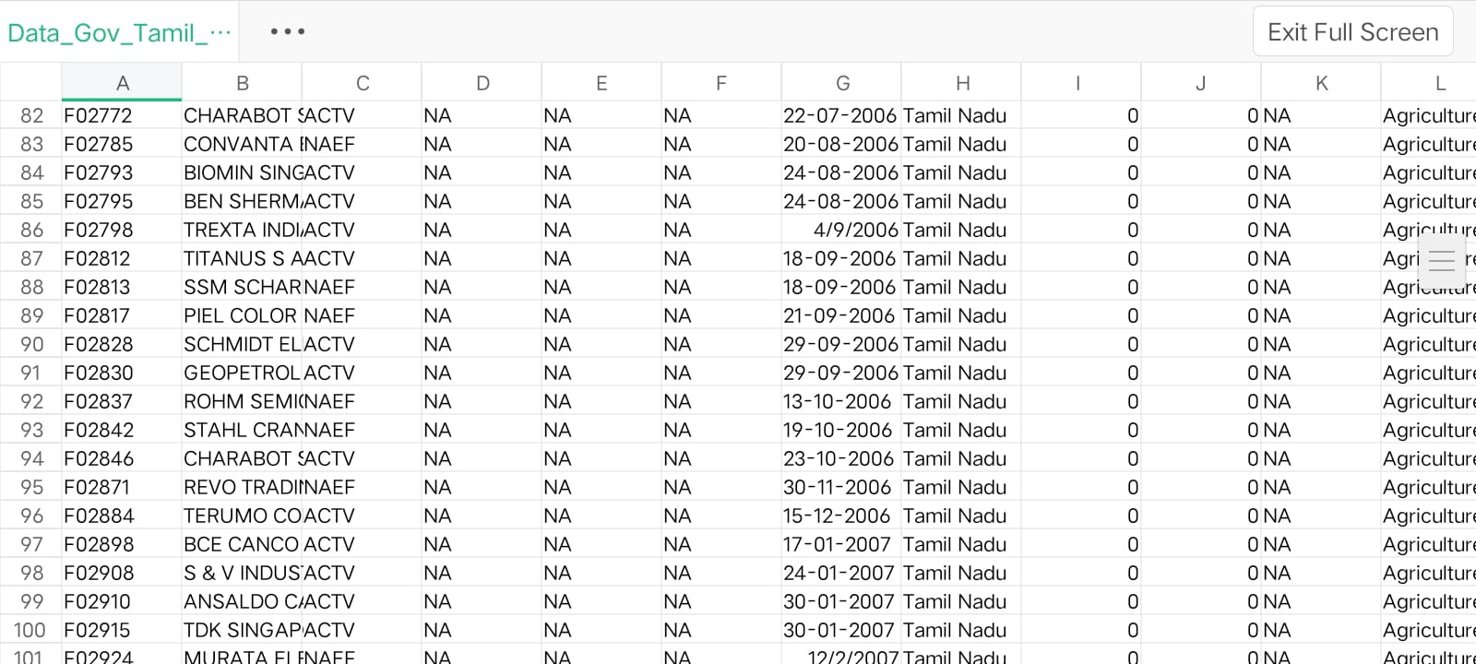

**Necessary step to follow:**

**Import Libraries:**

**Start by importing the necessary libraries:**

**Program:**

import pandas as pd

import numpy as np

from sklearn.model_selection import train_test_split

from sklearn.preprocessing import StandardScaler

**Load the Dataset:**

Load your dataset into a Pandas DataFrame. You can typically find

house price datasets in CSV format, but you can adapt this code to other

formats as needed.

<https://tn.data.gov.in/resource/company-master-data-tamil-nadu-upto-28th-february-2019>

# Load your CSV data into a DataFrame

data = pd.read_csv(‘Data_Gov_Tamil_Nadu.csv’)

# Separate the features (X) and the target variable (y)

X = data.drop('target_column_name', axis=1) # Replace 'target_column_name' with your actual target column

y = data['target_column_name']

**Exploratory Data Analysis (EDA):**

Perform EDA to understand your data better. This includes

checking for missing values, exploring the data's statistics, and

visualizing it to identify patterns

**Program:**

# Check for missing values

print(df.isnull().sum())

# Explore statistics

print(df.describe())

# Visualize the data (e.g., histograms, scatter plots, etc.)

**Feature Engineering:**

Depending on your dataset, you may need to create new features or

transform existing ones. This can involve one-hot encoding categorical

variables, handling date/time data, or scaling numerical features.

# Split the data into training and testing sets

X_train, X_test, y_train, y_test = train_test_split(X, y, test_size=0.2, random_state=42)

# Initialize and train the ensemble model (Random Forest in this example)

ensemble_model = RandomForestClassifier(n_estimators=100, random_state=42)

ensemble_model.fit(X_train, y_train)

**Split the Data:**

Split your dataset into training and testing sets. This helps you evaluate

your model's performance later.

X = df.drop('price', axis=1) # Features

y = df['price'] # Target variable

X_train, X_test, y_train, y_test = train_test_split(X, y, test_size=0.2,

random_state=42)

**Feature Scaling:**

Apply feature scaling to normalize your data, ensuring that all

features have similar scales. Standardization (scaling to mean=0 and

std=1) is a common choice.

**Program:**

scaler = StandardScaler()

X_train = scaler.fit_transform(X_train)

X_test = scaler.transform(X_test)

# Make predictions on the test data

y_pred = ensemble_model.predict(X_test)

**Importance of loading and processing dataset:**

Loading and preprocessing the dataset is an important first step in

building any machine learning model. However, it is especially

important for house price prediction models, company (ROC) datasets are

often complex and noisy.

By loading and preprocessing the dataset, we can ensure that the

machine learning algorithm is able to learn from the data effectively and

accurately.

**Challenges involved in loading and preprocessing a company trends**

**dataset;**

There are a number of challenges involved in loading and preprocessing

a company (ROC) dataset, including:

* **Handling missing values:**

House price datasets often contain missing values, which can

be due to a variety of factors, such as human error or incomplete data

collection. Common methods for handling missing values include

dropping the rows with missing values, imputing the missing values with

the mean or median of the feature, or using a more sophisticated method

such as multiple imputation.

* **Encoding categorical variables:**

House price datasets often contain categorical features, such as the

type of house, the neighborhood, and the school district. These features

need to be encoded before they can be used by machine learning models.

One common way to encode categorical variables is to use one-hot

Encoding

* **Scaling the features:**

It is often helpful to scale the features before training a

machine learning model. This can help to improve the performance of

the model and make it more robust to outliers. There are a variety of

ways to scale the features, such as min-max scaling and standard scaling.

* **Splitting the dataset into training and testing sets:**

Once the data has been pre-processed, we need to split the

dataset into training and testing sets. The training set will be used to

train the model, and the testing set will be used to evaluate the

performance of the model on unseen data. It is important to split the

dataset in a way that is representative of the real world distribution of the

data.

**How to overcome the challenges of loading and preprocessing a**

**house price dataset:**

There are a number of things that can be done to overcome the

challenges of loading and preprocessing a house price dataset, including:

* **Use a data preprocessing library:**

There are a number of libraries available that can help with data

preprocessing tasks, such as handling missing values, encoding

categorical variables, and scaling the features.

* **Carefully consider the specific needs of your model:**

The best way to preprocess the data will depend on the specific

machine learning algorithm that you are using. It is important to

carefully consider the requirements of the algorithm and to preprocess

the data in a way that is compatible with the algorithm.

* **Validate the preprocessed data:**

It is important to validate the preprocessed data to ensure that it is

in a format that can be used by the machine learning algorithm and that

it is of high quality. This can be done by inspecting the data visually or

by using statistical methods

.

**1.Loading the dataset:**

Loading the dataset using machine learning is the process of bringing⎫

the data into the machine learning environment so that it can be used

to train and evaluate a model.

The specific steps involved in loading the dataset will vary depending⎫

on the machine learning library or framework that is being used.

However, there are some general steps that are common to most

machine learning frameworks:

**a.Identify the dataset:**

The first step is to identify the dataset that you want to load. This

dataset may be stored in a local file, in a database, or in a cloud storage

service.

**b.Load the dataset:**

Once you have identified the dataset, you need to load it into the

machine learning environment. This may involve using a built-in

function in the machine learning library, or it may involve writing your

own code.

**c.Preprocess the dataset:**

Once the dataset is loaded into the machine learning environment,

you may need to preprocess it before you can start training and

evaluating your model. This may involve cleaning the data, transforming

the data into a suitable format, and splitting the data into training and

test sets.

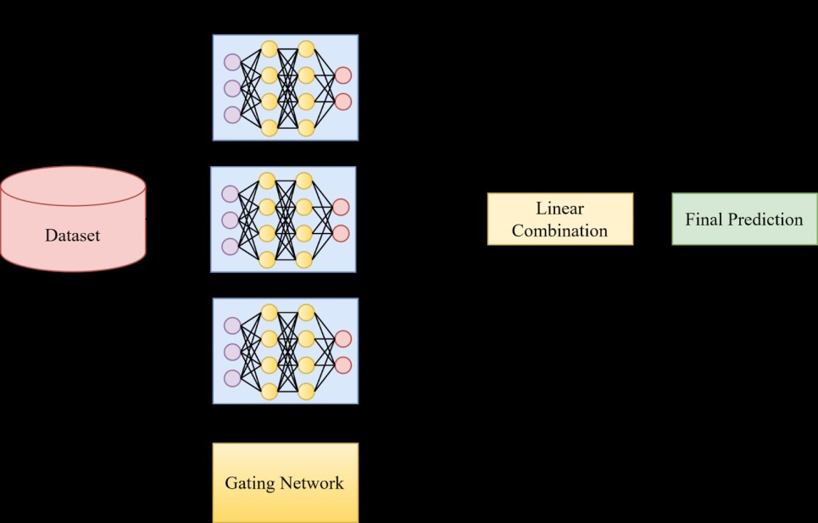

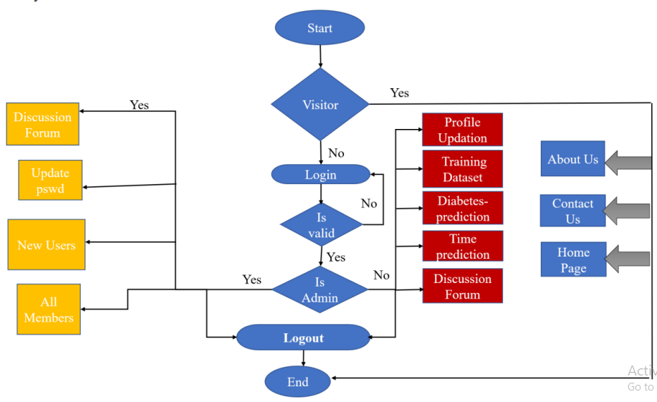

**Program:**

import pandas as pd

from sklearn.model_selection import train_test_split

from sklearn.ensemble import RandomForestClassifier # You can choose a different ensemble method as needed

from sklearn.metrics import accuracy_score

# Load your CSV data into a DataFrame

data = pd.read_csv(Data_Gov_Tamil_Nadu.csv)

# Separate the features (X) and the target variable (y)

X = data.drop('target_column_name', axis=1) # Replace 'target_column_name' with your actual target column

y = data['target_column_name']

# Split the data into training and testing sets

X_train, X_test, y_train, y_test = train_test_split(X, y, test_size=0.2, random_state=42)

# Initialize and train the ensemble model (Random Forest in this example)

ensemble_model = RandomForestClassifier(n_estimators=100, random_state=42)

ensemble_model.fit(X_train, y_train)

# Make predictions on the test data

y_pred = ensemble_model.predict(X_test)

# Evaluate the model's performance

accuracy = accuracy_score(y_test, y_pred)

print(f'Accuracy: {accuracy}'

**Loading Dataset:**

dataset = pd.read_csv(‘C:\Users\ELCOT\Downloads’)

**OUTPUT:**

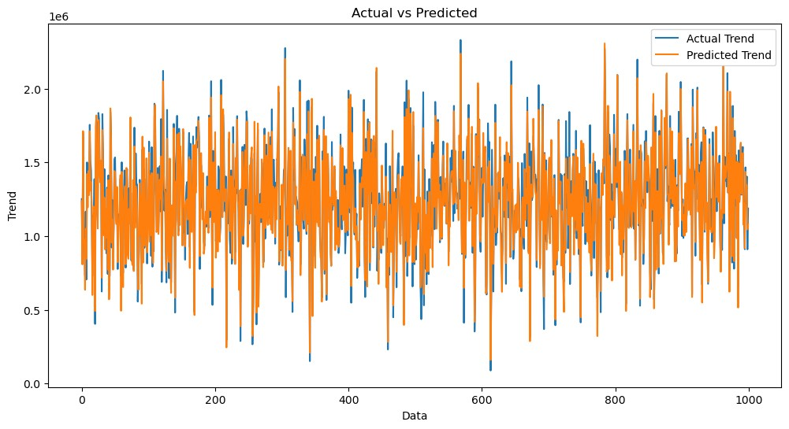

**Exploration and Prediction**

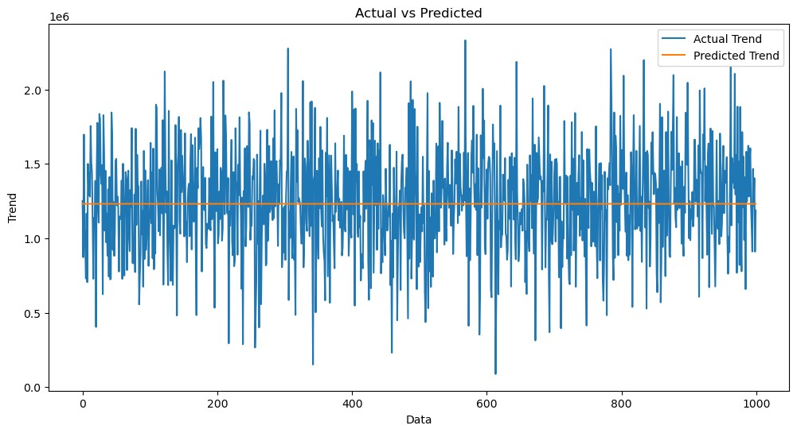

**Preprocessing the dataset:**

Data preprocessing is the process of cleaning, transforming, andϖ integrating data in order to make it ready for analysis. This may involve removing errors and inconsistencies, handling

missing values, transforming the data into a consistent format, and

scaling the data to a suitable range.

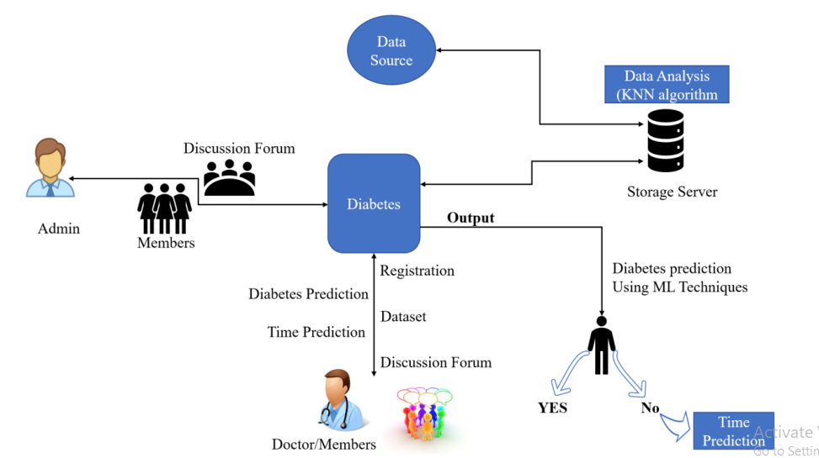

**Visualisation and Pre-Processing of Data:**

In [1]:

sns.histplot(dataset, x='Price', bins=50, color='y')

Out[1]:

<Axes: xlabel='Price', ylabel='Count'>

**CONCLUSION:**

**In conclusion, machine learning offers a promising approach for Ai driven company details prediction and risk assessment. By leveraging the power of data and advanced algorithms, it is possible to build models that can assist in identifying individuals at risk of diabetes. Here are some key takeaways:**

**Data is Key: High-quality, well-curated healthcare data is essential for building accurate in Ai driven data exploration prediction models. The quality of predictions is closely tied to the quality of the data.**

**Feature Engineering: Thoughtful feature engineering is crucial. The choice of features and their transformations can significantly impact the predictive performance of the model.**

**Model Selection: The choice of the machine learning algorithm should be based on the nature of the data and the problem at hand. Common choices include logistic regression, decision trees, random forests, support vector machines, and neural networks.**

**Evaluation Metrics: Model performance should be evaluated using appropriate metrics for classification tasks, such as accuracy, precision, recall, F1 score, and area under the ROC curve. It's important to consider the specific context and the trade-offs between false positives and false negatives.**

**Validation and Cross-Validation: To assess a model's generalization performance and minimize overfitting, use techniques like k-fold cross-validation.**

**Interpretability: In healthcare, model interpretability is critical. It's important to understand why a model makes certain predictions, especially for regulatory and ethical reasons.**

**Data Privacy and Ethics: in this module the following company RoC's has been used to classify that prediction of the profit range and following details.**

**Model Deployment and Monitoring: Deploying a model into a real-world healthcare setting requires careful consideration of integration, monitoring, and ongoing maintenance to ensure its continued effectiveness.**

**Collaboration with Different company Professionals: Machine learning models for the Ai driven company prediction should be developed in collaboration with corresponding company RoC's to experts who can provide domain knowledge and validate the model's outputs.**

**Ethical and Social Implications: Be aware of the ethical and social implications of company detail prediction models. Avoid perpetuating bias and disparities in healthcare outcomes.**

**In summary, machine learning for Ai driven model from the company registrar and prediction has the potential to make a significant positive impact on healthcare by enabling early identification of at-risk individuals, personalized treatment plans, and improved patient outcomes. However, it must be approached with care, responsibility, and a deep understanding of both the data and the healthcare domain. Collaboration between data scientists, healthcare professionals, and data privacy experts is key to the successful development and deployment of such models.**